Using Word properly
Dr Jim Briggs, 8 December 2010

Table of contents
1 Introduction 1
2 Styles 2
2.1 My standard style sheet 2
3 Heading 1 2
3.1 Heading 2 2
3.1.1 Heading 3 2
3.2 My preferred paragraph settings 3
4 Forms 3
5 Structured information 4
5.1 Cons of tabular layout 4
5.2 Pros of tabular layout 4
6 Tips 4
7 Converting documents 5
8 Referencing 5

Introduction
Do you use Microsoft Word? Do you use it "properly"?
I don't think anyone can claim to be able to use all its features to the maximum effect, but there is considerable evidence from documents sent to me electronically (from both students and fellow staff) that even some of what I would regard as basic features are not used effectively.
There are two important factors with documents that impact on all of us.
First is the importance to an organisation of its staff being able to share information effectively. 87% of business information is said to be encapsulated in text documents (rather than, for example, in databases). Much of this information does have organisation and structure – it is not totally freeform. Some of the structure is in the form of tabular relationships; some of it is hierarchical, such as the chapter/section structure of a report. Some of it is in the form of the document's navigation features – things like tables of contents, citations, cross references. To facilitate sharing, it is important to sustain whatever structure there is, so that wherever possible the structure does not have to be reconstituted when/if the information is reused.
Second is the recognition that form should be separate from content. What something represents is a separate issue from what it looks like. Form is about the aesthetic aspects of information presentation – this is important. Part of this is about consistency of presentation – what is the same should look the same, and things that are different should look different.
In this document, we look at how the features of Microsoft Word can be used to sustain the structure of information and present it consistently. We will look at consistent presentation first.

Styles
A first-time user of Word might be reassured that there is a highlighted box in their ribbon bar marked "Normal" (see Figure 1 below).
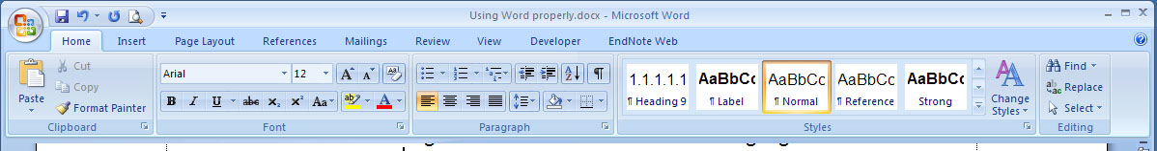
Figure 1 MS-Word Menu Ribbon
I want to assure everyone that it is OK to be "abnormal"!
Using styles is essential to ensure that the layout and format of a document is consistent. There is nothing worse than a document where the text appears in a seemingly random assortment of fonts and font sizes.
Styles will also ensure consistent numbering of the sections of your document, and the automatic numbering of list items.
Styles are the nearest equivalent in word processing to strong typing in programming languages. By strong typing, I don't mean hitting the keyboard hard.

My standard style sheet
My standard style sheet includes a set of commonly used styles with shortcut keys. Their purpose is as follows:
Style name | Shortcut key
Body Text | F2
- List number | F3
- List bullet | F4
Heading 1 | F5
Heading 2 | F7
Heading 3 | Shift-F5
Heading 4 | Shift-F7
Title | F8
Body Single | F9
- Code line | F6
The most important consideration in using these styles is that you provide the content first and apply the appropriate visual format later. Having the styles readily accessible via the function keys means that you can type the content of a paragraph and format it according to its purpose in any order.
It is important that the content of the document reflects its abstract structure. One example of this is in the use of paragraph separators (the newline character). Many people type two newlines to separate a paragraph from its successor. This has the effect of leaving a blank line between the paragraphs. This is the wrong implementation for achieving this visual effect – there should be only one newline because "logically" you need only one separator to separate two things. The "proper" way to get space between paragraphs is to set the spacing before and after each paragraph (see below).
Doing otherwise risks the wrong structure being inferred, especially when the context is changed – this could be as simple as moving the text near to the end of a page (pagination might well be compromised) or as complex as when translating a document into another format (e.g. HTML) automatically.

My preferred paragraph settings
The images below show the paragraph settings I prefer.
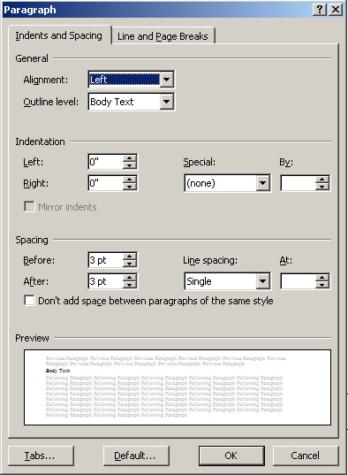  Figure 2 -- Paragraph settings tab 1 | 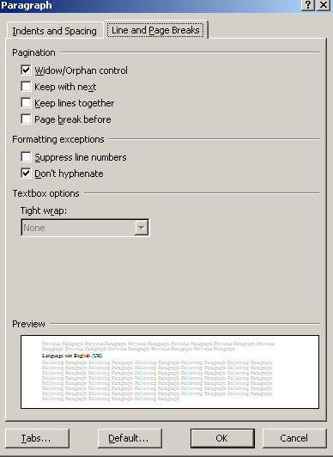  Figure 3-- Paragraph settings tab 2

Forms
When designing a form, make it easy for the user to fill it in without disturbing the format or layout unnecessarily.
One way to achieve this is by keeping the labels or questions in separate table boxes from the responses. For example:
Name |  | Date
Another way is to separate labels and responses into separate paragraphs. For example:
Reasons for decision:  Answer goes here. Format an empty line in the default style (e.g. Body Text) as a starting point. | Label in Label style  If you want a box to be a minimum size, set the row height property. Do NOT enter loads of blank lines.
A third (and perhaps the most "proper") way is to use Word's built-in form facilities, though I tend to find that they are clumsy for the end user – it can be difficult to edit the contents of a text box, for example. Word 2007 is much better than Word 2003 in this regard – one good reason (of many) to prefer DOCX format to the old DOC one.
This is some text in an automatically expanding box.

Structured information
If part of the information contained in your document is structured, use a table to lay it out. This means that anyone who copies the data from your document can probably retain the structure.
Cons of tabular layout  - Can't think of any | Pros of tabular layout  - Layout controlled by table  - Don’t need necessarily to have borders  - Text from long lines in the second column will never intrude into the first column
Never, ever include tab characters in your document like this.

Tips
- Make sure the language of all your styles is English (UK). There is nothing worse than being sent a document where correctly spelled words are underlined in red because the US spelling is different.
- Do you really need lots of whitespace on the page? Half a line (6pt at default font) is sufficient to clearly separate paragraphs. Double spacing is a technique spawned from the need to have space to make amendments to typewritten documents. Margins of more than 1-inch all round are a shocking waste of trees!
- Why would you want to set the indent of a paragraph outside the page boundaries? I've seen documents with 2" margins, and text indented -1.0" so that it appears in the conventional position on the paper. Set the boundary of the page and work within it.
- Using the heading styles means that it is trivial to automatically generate (and update) the Table of Contents on the first page.
- Don't forget to insert page numbers in your documents. Page numbering is an important aspect of document navigation.

Converting documents
A properly formatted Word document should convert cleanly into HTML format for publication on a website. It is usually preferable for documents posted on websites to be in HTML format – the one exception to this would be something that was specifically intended to be printed, in which case PDF is probably the best format that doesn't allow the user to change the content.
PDF documents can be produced easily from Word (and any other program) using the Cute PDF pseudo-printer (Acro Software Inc, n.d.).

Referencing
I have now adopted EndNoteWeb (Thomson Reuters, n.d.) as my standard referencing software. This gives you the option of entering references by several means, including searching common databases, entering them by hand, or importing them from existing documents that use EndNote or Word reference format. It also allows you to share groups of references with your friends (or colleagues). You can download a Word plug-in that supports all these features.
References

Acro Software Inc. (n.d.). CutePDF. from http://www.cutepdf.com/
Thomson Reuters. (n.d.). EndNote Web. from http://www.myendnoteweb.com

When you need to include a cross-reference like this, use Word's Cross-reference facility.
This paragraph has the "Keep with next" pagination attribute switched on so that it will always appear on the same page as the succeeding table. That's why there could be some whitespace at the bottom of the previous page.

